MyCommPal | Real User Feedback Evidence
  - Buildathon supporting document • Early qualitative feedback from WhatsApp
Screenshots are drawn from the supplied Assignment 4 research document. Confirm that they represent at least 3 distinct testers before submission. Feedback is qualitative, reflects different application versions, and does not independently prove articulation improvement.

01 Users choose Vira for practice
“To learn new concepts i would use chatgpt but for practice i would use vira.”
What we learned: A tester recognizes the specialized practice journey as distinct from concept learning with a general AI assistant.
Product action / hypothesis: Retain focused, scenario-based diagnosis → guidance → practice → reflection.
Implementation status: To be confirmed against the current production build; no user retest evidence included in the research dump.
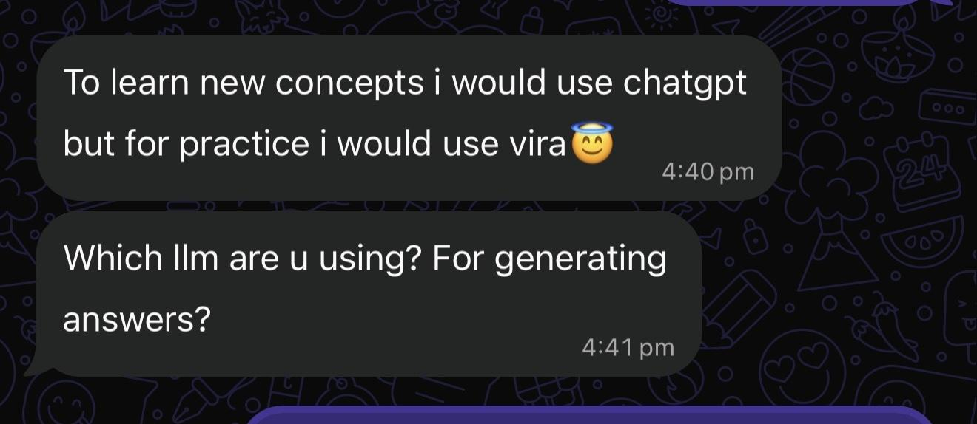
Source: WhatsApp screenshot supplied in Assignment 4; identifying details should be reviewed before sharing externally.

02 Guided mentoring is easy to follow
“Working on one thing at a time also makes the advice easier to follow.”
What we learned: The tester valued clean design, guest entry, realistic situations, and one focus at a time.
Product action / hypothesis: Preserve one recommended improvement upfront; make deeper guidance accessible.
Implementation status: To be confirmed against the current production build; no user retest evidence included in the research dump.
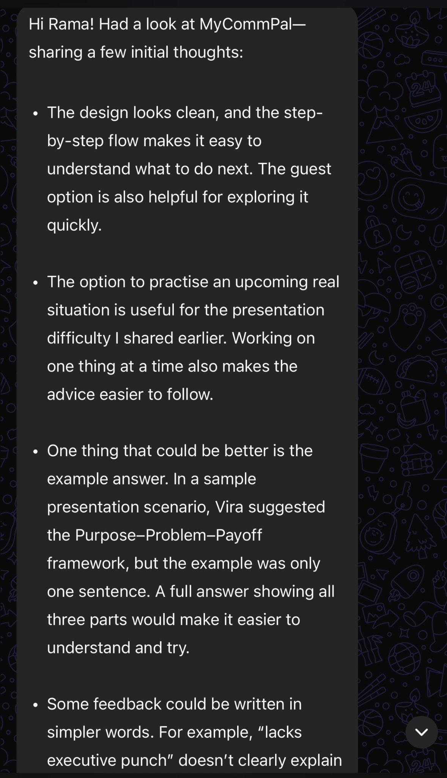
Source: WhatsApp screenshot supplied in Assignment 4; identifying details should be reviewed before sharing externally.

03 Learning guidance was hard to find
“No i couldn’t find it.”
What we learned: The tester wanted concepts before retrying but could not locate Deep Dive framework explanations.
Product action / hypothesis: Provide a visible “Learn this technique” path and test discoverability.
Implementation status: To be confirmed against the current production build; no user retest evidence included in the research dump.
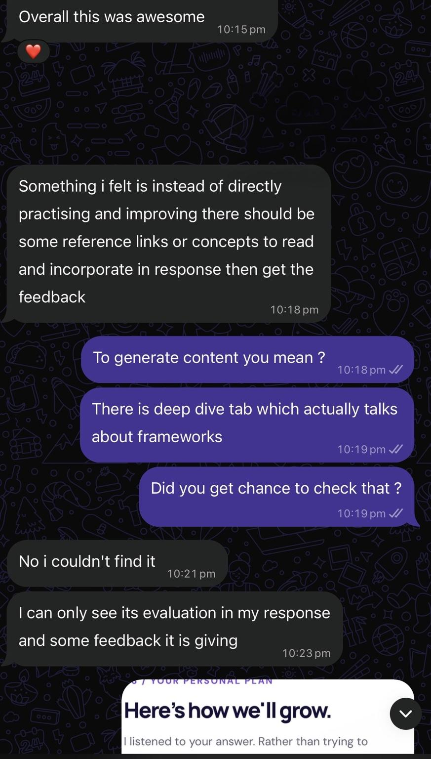
Source: WhatsApp screenshot supplied in Assignment 4; identifying details should be reviewed before sharing externally.

04 Voice transcription blocked progress
“Speech to text is typing multiple times.”
What we learned: The tester reported repeated transcription, >3,000 characters and an unavailable assessment action.
Product action / hypothesis: Retest deduplication, validation state, and microphone behavior on mobile.
Implementation status: To be confirmed against the current production build; no user retest evidence included in the research dump.
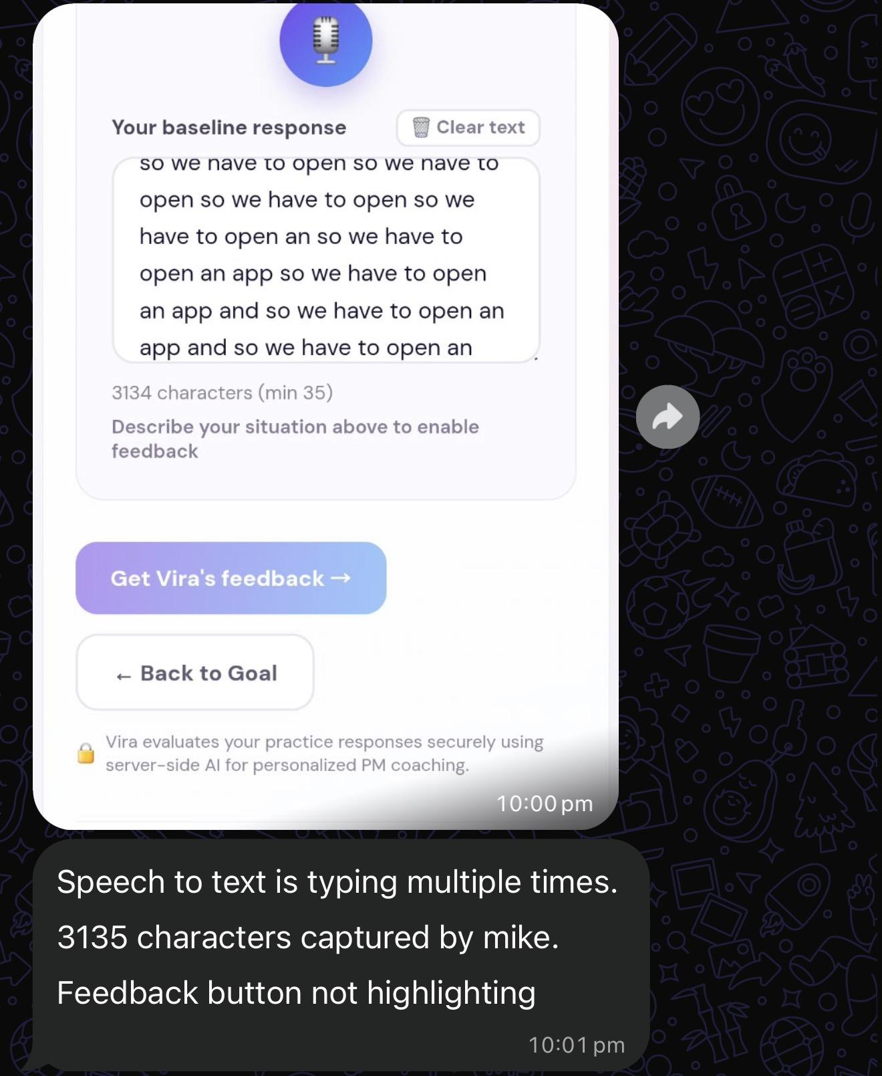
Source: WhatsApp screenshot supplied in Assignment 4; identifying details should be reviewed before sharing externally.

05 Progress and navigation were inconsistent
“Streak shows 1 day … [but] No completed practice session yet.”
What we learned: Streak/history disagreement and unexplained disabled steps can undermine user trust.
Product action / hypothesis: Align streaks with completed sessions and explain step prerequisites.
Implementation status: To be confirmed against the current production build; no user retest evidence included in the research dump.
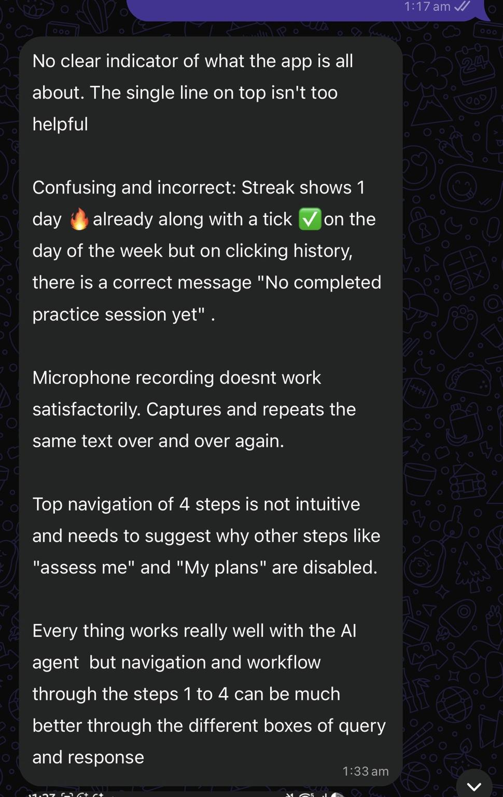
Source: WhatsApp screenshot supplied in Assignment 4; identifying details should be reviewed before sharing externally.

Summary: Feedback → Product decisions
Finding | Priority | Validation required
Microphone duplication / cut-off | P0 | Repeat voice tests on Android and iOS browsers
Missing practice comparison / session carryover | P0 | Verify independent attempts, scores, and session reset
Framework discovery / plain-language advice | P1 | Observe first-time users finding learning content
Streak/history disagreement / locked-step confusion | P0 | Validate progress logic and explain unavailable steps
Practice-focused differentiation | Retain | Test actionability vs strong ChatGPT baseline
Evidence boundary: User testimonials support perceived value, not measured skill gains. Do not represent product decisions as completed engineering fixes without deployment/retest proof.

